Core Concepts Covered
Volumes in Kubernetes Pods
  - Volumes are a directory accessible to containers in a pod and provide storage.
  - emptyDir volume is ephemeral and lasts only for the Pod lifecycle. Data stored in emptyDir is lost when the Pod is deleted or recreated, but it remains if only the container is restarted.
  - Persistent storage is necessary for stateful applications to survive Pod restarts, rescheduling, or scaling.
Persistent Volume (PV) and Persistent Volume Claim (PVC)
  - PV: A cluster-wide storage resource (e.g., NFS, cloud disk) provisioned by the storage admin; represents a pool of storage (e.g., 100Gi).
  - PVC: Pod-level request for storage, bound to a PV. Created by the user; claims a specific size and access mode from the PV.
  - Kubernetes scheduler matches PVC requests with available PVs based on capacity and access modes. Once bound, a PVC reserves a portion of the PV’s total capacity.
- Access Modes- Kubernetes supports several access modes for volumes, which must match between PV and PVC:
Access Mode | Description
ReadWriteOnce (RWO) | Volume can be mounted as read-write by a single node
ReadOnlyMany (ROX) | Volume can be mounted read-only by many nodes
ReadWriteMany (RWX) | Volume can be mounted as read-write by many nodes
Binding and Capacity Management
  - PVCs bind to PVs that satisfy their request (capacity, access mode, storage class)
  - After binding, the PV capacity is reduced by the size claimed by the PVC.
  - PVC remains in pending state if no suitable PV is available (capacity or access mode mismatch). Example scenarios:
    - PVC requests more storage than available → remains pending.
    - PVC requests storage but with incompatible access mode → remains pending.
Reclaim Policies for PVs
Defines what happens to PV when PVC is deleted:
Policy | Description
Retain | PV remains but is marked released; data is preserved, not reusable immediately. manual cleanup required.
Delete | PV and underlying storage are deleted automatically when PVC is deleted
Recycle | PV is scrubbed and made available again for new claims (deprecated)
# Create a PersistentVolume
kubectl create pv my-pv --capacity=1Gi --access-modes=ReadWriteOnce --storage-class=manual
# Create a PersistentVolumeClaim
kubectl create pvc my-pvc --storage-class=manual --access-modes=ReadWriteOnce --resources=1Gi
# Create a StorageClass (example with hostPath provisioner)
kubectl create -f storageclass.yaml
# Inspect volumes
kubectl get pv
kubectl get pvc
kubectl describe pv my-pv
kubectl describe pvc my-pvc
HostPath Volumes and Limitations
  - HostPath mounts a directory from the node’s filesystem into a Pod.
  - Suitable only for single-node or test clusters, not recommended for production multi-node clusters.
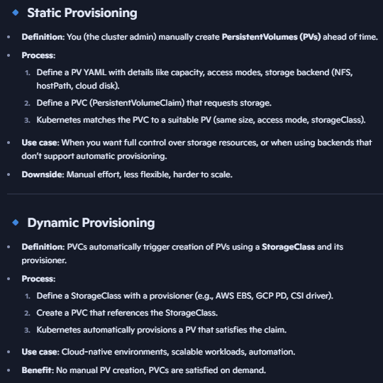
Storage Classes- Abstracts different types of physical storage backends (cloud providers, networked storage, local storage). Defines dynamic provisioning rules (provisioner, reclaim policy, parameters).
  - Defines provisioner that manages storage resources (e.g., AWS EBS, Azure File, NFS). It is a plugin/driver that knows how to create storage volumes. Examples:
kubernetes.io/aws-ebs → AWS Elastic Block Store
kubernetes.io/gce-pd → Google Persistent Disk
kubernetes.io/no-provisioner → No dynamic provisioning (manual PVs only)
CSI drivers (modern standard): csi.azure.com, csi.cephfs.csi.k8s.io, etc.
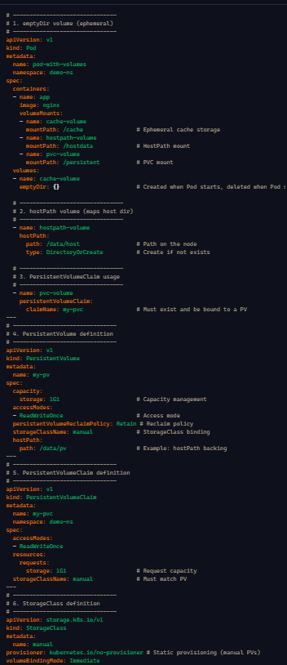
  - Users specify storage class in PVC and PV to associate volumes with specific backend storage.
  - Enables dynamic provisioning of volumes without pre-creating PVs.
  - Multiple storage classes can exist; one can be marked as default.

